Wright Brothers’ First Flight
Fake News?
Wright Brothers National Memorial

Location: Classroom
Grade: 4th Grade
Subject: English Language Arts
Duration: 2 60 minute sessions
Key Vocabulary: embellishment, exaggeration, media, journalism
North Carolina State Standards:
RI.4.3 Explain events, procedures, ideas, or concepts in a historical, scientific, or technical text including what happened and why, based on specific information in the text.
Materials:
Copies of Orville’s journal entry of 12/17/1903
Copies of the Virginian Pilot news article
Highlighters
Copy of the telegram sent to Wright brother’s father
Comparison Chart

Site Significance: Orville and Wilbur Wright were aviation pioneers that succeeded in creating and successfully flying the first powered, heavier than air flying machine that would ultimately impact the world. This historic event was recorded in Kill Devil Hills located in Kitty Hawk, North Carolina on December 17, 1903.
RI.4.6 Compare and contrast a firsthand and secondhand account of the same event or topic; describe the differences in focus and the information provided.

Objectives: The student will be able to:
- compare 2 texts about the same event and identify discrepancies
- understand that inaccuracies in reporting may be due to bias, ignorance, absence or other factors

Essential Question: Does the news media impact our view of current events and is it our responsibility as citizens to look for accurate and reliable information?
Method: Students will compare 3 texts about the Wright brothers’ first flight - Orville’s entry of the event, the telegram that was sent to Wright’s father and an article published in the Virginian Pilot on 12/18/1903.
Background:
http://www.wright-brothers.org/History_Wing/Wright_Story/Inventing_the_Airplane/December_17_1903/Virginia_Pilot_Story.htm
ilbur and Orville strode into the Kitty Hawk Weather Bureau on the afternoon of December 17, 1903 and asked to use their telegraph to inform their family in Dayton, Ohio of their successful flight. The telegraph operator, John Dosher, sent the message. But as they were about to leave, a message came back from Jim Gray, the telegraph operator in Norfolk through whom the message had been relayed -- asking if he could inform his local newspaper. The Wrights politely refused, they wanted the story to come out of Dayton. Their father Milton and their brother Lorin were all primed to act as their press agents.
Jim Gray, however, ignored their request and told his friend, Ed Dean, a reporter at the Norfolk Virginian-Pilot. Dean, his editor Keville Glennan, and Harry Moore (who worked in the circulation department) all put their heads together to flesh out the sparse details and create a story worth reading. The resulting news article was certainly interesting, but bore not even a vague resemblance to the truth. And to make matters worse, the Virginian-Pilot distributed this made-up story on the Associated Press wire service and it was printed in whole or in part in dozens of newspapers across the country.
On January 5, 1904, the Wright brothers issued a statement to the Associated Press, calling the Virginian-Pilot article "...fictitious story incorrect in almost every detail" and offering a truthful account. Their statement was circulated, but few newspapers bothered to print the corrections. The truth was not nearly as gripping as the fiction

Suggested Procedure
- Use read aloud books listed under suggested resources so students are familiar with the Wright brothers’ story.
- Explain to students that Orville kept a journal to document all of their experiments and discoveries. Ask students if they think this was important to inventors. Why? Tell them that you have a copy of Orville’s journal entry on December 17, 1903.
- Make copies of the journal entry of December 17th and distribute to each student. Give each student a highlighter.
- Read the journal entry aloud all the way through so students can get a mental image. Reread the entry having them highlight important information as you read such as: wind speed, who was flying, witnesses, distance and time of each flight, how high the flyer flew, how each of the 4 trials ended, and how the flyer was damaged after the trials.
- Explain to students that the Wrights wanted to let their father know about their success by telegram. They also wanted their father and brother to be the ones to tell the press in Ohio about the story. They sent the telegram from the lifesaving station which relayed it to Norfolk. From there it went to Ohio to their father. Display a copy of the telegram for students to see. (see additional resources) Read it aloud and see if students pick up on the mistakes. (57 instead of 59 seconds and Orville’s name is spelled wrong.) Ask how that might have happened.
- Ask them if they have heard the term “fake news” recently. What does it mean? How does fake news get started? How do we know if news is accurate? Can students give you an example of how the “truth” became distorted in their lives and what consequences followed?
- Tell the story from the background information listed above about how the telegram information was leaked to the Virginian Pilot newspaper. The telegram was the only information they had to go by when they wrote their story.
- Pair students up and give each pair a copy of the actual newspaper article. Read the article aloud as students follow along. Does this sound accurate? How did the Virginian Pilot gather all of that information from the telegram? Why do they think the newspaper published such a fabricated story?
- Give each pair of students a copy of the comparison chart. Have them go through the journal entry and the newspaper article and fill in the chart with information from both texts. They should also answer the questions at the bottom of the chart for class discussion.
- After students have had time to complete the chart and questions, have a class discussion about their findings. If available, use a chart to display and fill in as you discuss. Chart paper would also work. Would they consider the telegram “fake news” or was that just due to human error? What about the newspaper article? Was it based on an actual experience or was it entirely made up? Is anything accurate in the article?
- Sample discussion questions could include: Should you believe everything you read or hear through the news media? Do we have a responsibility to search for accuracy in reporting? What are some ways to check out news stories to see if they are real or not? What news sources do your parents use? Do they use more than one source? This could open up many possibilities for discussion.
- The link below leads you to an article that was written in the Virginian Pilot on December 17, 2003 that corrects the errors in the first article. Teachers can use this resource to point out all of the specific errors made.

Evaluation: The comparison chart and discussions in class
Extensions:
- Students could write their own newspaper version of the first flight using accurate details from Orville’s journal. This could also be used as an assessment to check for understanding.
- Read the interview from eyewitness John Daniels that was given in 1927. Note the inaccuracies in this account. Why do you think an eyewitness got so many things wrong?

Additional Resources
Websites:
- A copy of Orville’s journal entry
https://www.libraries.wright.edu/special/wrightbrothers/packet/orville
- The original Virginian Pilot article - : http://www.wright-brothers.org/History_Wing/Wright_Story/Inventing_the_Airplane/December_17_1903/Virginia_Pilot_Story.htm
- The telegram sent to the Wright’s father (a copy of the telegram in included in this lesson plan:
https://airandspace.si.edu/exhibitions/wright-brothers/online/artifactgallery/?id=5753
- This link takes you to an interview of eyewitness, John Daniels that was taken in 1927. It too contains some errors.
https://maritime-executive.com/article/coast-guardsmen-pioneered-flight-with-wright-brothers#gs.fdrTqNU

https://wrightstories.com/wrights-first-flight-distorted-by-press/

https://www.nps.gov/wrbr/index.htm
Books: Who Were the Wright Brothers? James Buckley, Jr
The Wright Brothers’ Glider Gerry Bailey and Karen Foster
You Wouldn’t Want to Be on the First Flying Machine! Ian Graham
The Wright Brothers: Inventors Whose Ideas Really Took Flight Mike Venezia
Comparison Chart of the First Successful Flight

 | Orville’s Journal | Virginian-Pilot Article
When did the flights take place (Date)
Where did the flights take place?
Who flew the plane on the first successful trial?
How long did the first flight last?
How high did the flyer go?
What was the wind speed?
Was the plane launched from an incline or flat ground?
How did the flight end?

Who witnessed the flight?

- Why do you think the newspaper account of the first flight is so different from what actually happened?

- Did you notice anything else that was inaccurate in the newspaper article? If so, list them below.

- Do you think the readers of the article believed what was written? Why or why not?

- Look up the word “embellish”. What does it mean and how does it relate to the newspaper article?

- Would you consider this article “fake news” since it was based on an actual event? Explain.

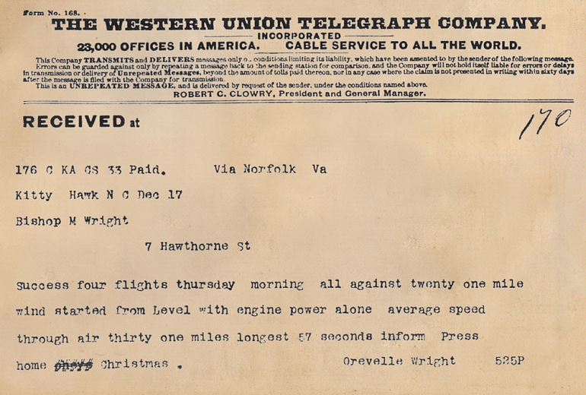

Flying Machine Soars Three Miles in Teeth of High Wind Over Sand Hills and Waves On Carolina Coast  No Balloon Attached To Aid It  Three Years of Hard, Secret Work By Two Ohio Brothers Crowned With Success  Accomplished What Langley Failed At  With Man As Passenger Huge Machine Flies Like Bird Under Perfect Control  Box Kite Principle With Two Propellers  The problem of aerial navigation without the use of a balloon has been solved at last.  Over the sand hills of the North Carolina coast yesterday, near Kitty Hawk, two Ohio men proved that they could soar through the air in a flying machine of their own construction, with the power to steer it and speed it at will. This, too, in the face of a wind blowing at the confirmed velocity of twenty-one miles an hour.  Like a monster bird, the invention hovered above the breakers and circled over the rolling sand hills at the command of its navigator and, after soaring for three miles, it gracefully descended to earth again and rested lightly upon the spot selected by the man in the car as a suitable landing place.  While the United States government has been spending thousands of dollars in an effort to make practicable the ideas of Professor Langley of the Smithsonian Institute, Wilbur and Orville Wright, two brothers, natives of Dayton, O., have quietly, even secretly, perfected their invention, and put it to a successful test.  They are not yet ready that the world should know the methods they have adopted in conquering the air, but the Virginian-Pilot is able to state authentically the nature of their invention, its principle and its chief dimensions.  How the Machine Was Built  The idea of the box kite has been adhered to strictly in the basic formation of the flying machine.  A huge framework of light timbers, 33 feet wide, five feet deep and five feet across the top forms the machine proper.  This is covered with a tough, but light canvas.  In the center, and suspended just below the bottom plane is the small gasoline engine which furnishes the motive power for the propelling and elevating wheels.  There are two six-bladed propellers, one arranged just below the center of the frame, so gauged as to exert an upward force when in motion, and the other extends horizontally to the rear from the center of the car, furnishing the forward impetus.  Protruding from the center of the car is a huge fan-shaped rudder of canvass, stretch upon a frame of wood. This rudder is controlled by the navigator and may be moved to each side, raised or lowered.  Start Was Success  Wilbur Wright, the chief inventor of the machine, sat in the operator’s car and when all was ready his brother unfastened the catch which held the invention at the top of the slope.  The big box began to move slowly at first, acquiring velocity as it went, and when half way down the hundred feet the engine was started.  The propeller in the rear immediately began to revolve at a high rate of speed, and when the end of the incline was reached the machine shot out into space without a perceptible fall.  By this time the elevating propeller was also in motion, and, keeping its altitude, the machine slowly began to go higher and higher until it finally soared sixty feet above the ground.  Maintaining this height by the action of the under wheel, the navigator increased the revolutions of the rear propeller, and the forward speed of the huge affair increased until a velocity of eight miles an hour was attained.  All this time the machine headed into a twenty-one mile wind.  Coast Folk Amazed  The little crowd of fisher folk and coast guards, who have been watching the construction of the machine with unconcerned curiosity since September 1st, were amazed.  They endeavored to race over the sand and keep up with the thing of the air, but it soon distanced them and continued its flight alone, save the man in the car.  Steadily it pursued its way, first tacking to port, then to starboard, and then driving straight ahead.  “It is a success,” declared Orville Wright to the crowd on the beach after the first mile had been covered.  But the inventor waited. Not until he had accomplished three miles, putting the machine through all sorts of maneuvers en route, was he satisfied.  Then he selected a suitable place to land, and, gracefully circling, drew his invention slowly to the earth, where it settled, like some big bird, in the chosen spot.  “Eureka,” he cried, as did the alchemist of old. | 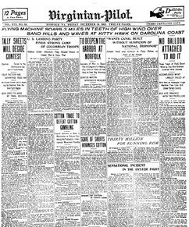  The first powered flight of the Wright Brothers made front page news in the Virginian-Pilot, but the story was

Correction that ran in the Virginian-Pilot December 17, 2003.

We'd like to set the record straight – a century later
- A story and headline in the Dec. 18, 1903, Virginian-Pilot contained errors.
- Orville Wright was the pilot for the first flight of the Wright Flyer. It was not Wilbur, whose name is not spelled Wilber.
- The plane's wing span was 40 feet, 4 inches. The wings were 6 feet 2 inches apart vertically and 6 feet, 6 inches from front to rear.
- They were covered in muslin, not canvas.
- The engine rested on top of the lower wing. It did not hang below it.
- The propellers had two blades each, not six. They both were mounted on the rear side of the wings. There was no propeller providing upward force.
- Rudders in the front and rear and warping of the wings controlled the plane. There was not a single, huge fan-shaped rudder that could be moved side to side and raised and lowered.
- The pilot lay prone on the lower wing. There was no pilot's car.
- The Wrights have always said they were equal inventors of the machine. Wilbur never took credit as the chief inventor.
- The brothers had no plans to build a much larger machine and never did.
- Their success came after four years of work, not three.
- They took one trip to the Outer Banks in the summer and two trips in the fall prior to 1903. They did not spend almost the entire winter, fall and early spring on the Outer Banks for three years.
- They arrived on Sept. 26 in 1903, not on Sept. 1.
- The plane took off under its own power after traveling 40 feet down a rail on flat land. It was not sent down a slope after Orville Wright released a catch.
- The engine was started before takeoff. It was not started after the plane had rolled halfway down a 100-foot hill.
- The plane flew 120 feet, 8 to 10 feet off the ground in a straight line on the first of four flights. It did not soar 60 feet in the air. It did not circle and fly 3 miles over breakers and dunes. It did not tack to port, then to starboard.

- The plane's ground speed was 8 to 10 mph. Its air speed was 30 to 35 mph. It did not fly at 8 mph.

- The plane hit the ground nose-first after its fourth flight, damaging the front rudder mechanism, and was later destroyed by a gust of wind. It did not descend gracefully and rest lightly at a spot chosen by the aviator after one attempt.

- Five onlookers helped the brothers and watched the flights. A small crowd did not run after the plane and give up after it outpaced them.

- The flight took place at the foot of Kill Devil Hill. Orville Wright did not declare the flight a success before a crowd on the beach after the first mile. The flights were not on the beach.

- Wilbur Wright was 5 feet 10 inches tall and weighed 140 pounds. His eyes were blue-gray and his hair dark brown. He was not 5 feet 6 inches tall and did not weigh 150 pounds. He did not have raven-hued hair. His eyes were not deep blue.

